**Detection and identification of individual drugs and narcotic substances. Phenylalkylamine derivatives**

**Properties and toxicological significance**

In toxicological chemistry, this group includes the natural alkaloid ephedrine, its diasteroisomer pseudoephedrine, as well as synthetic phenylalkylamine derivatives: ephedra, amphetamine and methamphetamine. Ephedrine has the greatest medical use. It is used as a vasoconstrictor and bronchodilator. Amphetamine is a psychostimulant. Its use is possible for asthenic phenomena after traumatic brain injuries, after prolonged bed rest.

The use of phenylalkylamine derivatives, especially amphetamine and related ones on the chemical structure of compounds, limited. This is due to the fact that side effects the effect of their action is a euphoric state, i.e. these derivatives have high drug addiction potential.

Natural phenylalkylamines:

|  |
| --- |
| **Ephedrine** |

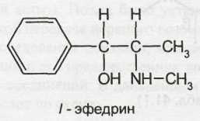

|  |
| --- |
| **Cathinone** |

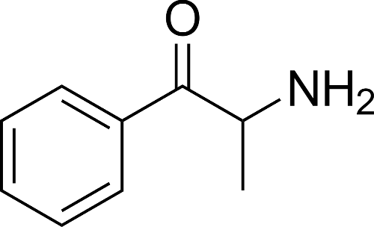

|  |
| --- |
| **Mescaline** |

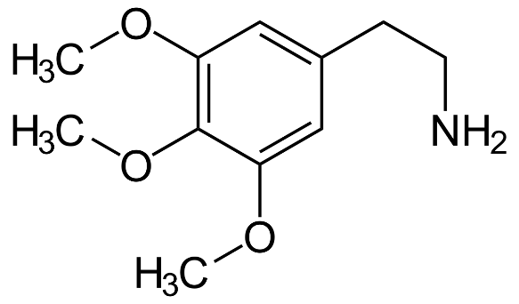

Synthetic phenylalkylamines:

|  |
| --- |
| **Mephedrone** |

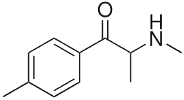

|  |
| --- |
| **Amphetamine** |

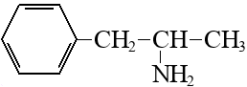

|  |
| --- |
| **Methamphetamine** |

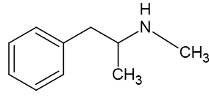

|  |
| --- |
| **Methylenedioxymethamphetamine (MDMA)** |

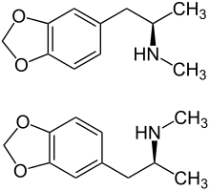

**Amphetamine**

* First synthesized in 1887 as analogue of ephedrine, and has received widespread spread in medicine in as a bronchodilator facilities.
* In the 20-30s of the 20th century it began to be used as a central nervous system stimulant, to suppress appetite, for the treatment of hypokinesia in children and narcolepsy.
* Main and heaviest the consequences of taking are: increased risk of stroke hypertension, arrhythmias, paranoid psychoses.
* To reduce appetite and increase activities were used one-time daily oral doses of 5 – 15 mg.
* Oral or intravenous daily the dose for drug addicts can reach up to 2000 mg.
* Included in the antidote for organophosphorus substances from army personal first aid kit "A1" - Athens.
* By increasing mood, physical activity, performance, and reducing fatigue, amphetamine and methamphetamine were used as doping agents means to increase sports performance. Currently, these drugs are under special control and prohibited for use by athletes.

**Methamphetamine** in the Russian Federation has been moved to List No. 1 of the Permanent Committee of the Russian Federation on Drug Control, and its circulation is completely prohibited.

• First synthesized in 1919.

• Illegally synthesized from phenylacetone and N-methylformamide is a racemate of ephedrine using red phosphorus and hydroiodic acid – d-isomer.

• As hydrochloride in single use oral doses of 2.5-15 mg abroad used to treat obesity. It is also available there in the form of tablets of 2.5- 5 mg or extended-release tablets actions 5-15 mg.

• Used for non-medical purposes by intravenous or intramuscular injection, orally, as well as by inhalation of vapors, after mixing with marijuana, tobacco or parsley.

• The most dangerous form is "ice" - crystalline form methamphetamine hydrochloride.

• Often used in mixtures with cocaine, heroin or other drugs.

Amphetamines initially cause a surge of energy, euphoria, loss of appetite, increased heart rate and respiration, and dilated pupils. Long-term use of amphetamines leads to rapid loss of weight, immunity, destruction of the lungs, liver, kidneys, deterioration of vision, dizziness, loss of coordination and collapse. Mental dependence develops very quickly - after 3-5 intravenous injections and after 2-3 weeks. irregular oral intake. Physical dependence is characterized by signs of withdrawal syndrome. Withdrawal syndrome occurs 9 hours after discontinuation of the drug and may last up to 10 weeks Due to developing tolerance, a single dose of amphetamine can reach up to 1 g, methamphetamine - up to 0.8 g.

Taking large doses (“overdose”) is accompanied by an increase in blood pressure, the appearance of a febrile state, toxic (“amphetamine”) psychoses, similar to paranoid schizophrenia, heart attacks and heart attacks.

**Ephedrine** is an alkaloid found in various types of ephedra (Ephedra, family Ephedracea). It is used in medical practice in the form of hydrochloride. It is prescribed to stimulate α- and β-adrenergic receptors, the central nervous system, to constrict blood vessels and reduce inflammatory processes in rhinitis, to increase blood pressure, during surgical interventions, with injuries, blood loss, with myasthenia gravis, narcolepsy (an irresistible desire to sleep), poisoning with sleeping pills and narcotics means, locally - as a vasoconstrictor, for bronchospasms and for dilating the pupil for diagnostic purposes.

Ephedrine is used in the form of powder, tablets, and injection solutions. Ephedrine hydrochloride is part of combination medications (“Teofedrin”, “Solutan”, “Broncholitin”, “Efatin”) and are prescribed for bronchospasms. Ephedrine can be addictive, which leads to mental and hearing impairment and olfactory hallucinations.

In forensic medical practice, ephedrine poisoning occurs when it is used as a hypertensive drug to artificially increase blood pressure. The clinic of acute poisoning (1-5 mg/kg) is characterized initially, insomnia, dizziness, tremors of limbs, palpitations, increased blood pressure, arrhythmia, followed by nausea, vomiting, urinary retention, central nervous system excitation, severe mental and motor restlessness, edema lungs, increased excitability of the respiratory center and its exhaustion.

**Ephedron (marchefal, jeff)** is a product of the oxidation of ephedrine. Its use was observed mainly in Russia. Abuse of this substance is called “ephedron addiction.” Ephedrone is classified by the Standing Committee of the Russian Federation on Narcotics to list No. 1, and its circulation in our country is prohibited.

Teenagers are beginning to abuse ephedron. Ephedrone is administered with a narcotic the goal is from 2 to 80 ml of a homemade product per day of unknown concentration. With increasing tolerance, the number of injections can reach up to 10 times a day and more. The narcotic effect develops immediately or after 15-20 minutes and lasts 6-8 hours. The state of intoxication is characterized by a feeling of euphoria, a surge of energy, lightness body, clarity of thought, increased ability to work. Patients are verbose, fussy, their activities are unproductive, they evaluate their state as “a state of happiness, immeasurable joy." When the drug is administered, vegetative-vascular changes are observed: there is a sensation of goosebumps, “the hair stands up on the head,” Tachycardia, dry mouth develops, and blood pressure rises. In patients severe neurological and mental disorders are observed. Psychoses are characterized by delusions of persecution, jealousy, anxiety, fear; patients are afraid of crowded places, cannot cross the street, use the subway, etc. At the same time they are looking for communication and are distinguished by verbosity, inconsistency, fussiness, and restlessness.

**Methyleneoxy derivatives of amphetamine**. This group of compounds is now widespread in many countries, including the Russian Federation, due to their ability to cause mild euphoria and a special mental state for which characterized by an aggravation of emotional perception, an increase in the strength of emotions and sensations. For a long time it was believed that these substances were safe and were used in psychiatry to relieve patient anxiety. When studying the consequences of using these drugs, reports appeared about harmful side effects, mental disorders and serious brain disorders. All compounds of this group under the UN Convention and the Permanent Drug Control Committee of the Russian Federation are prohibited for use and included in list No. 1.

MDA was first synthesized in 1910

* Widely distributed in illegal drug trafficking MDA received in America in late 60's - early 70's. and was known as
* Mellow Drug (Mellow tablets) or Love Drug (love pills).
* When taking small doses of MDA (less than 80 mg) a stimulating effect is achieved.
* In moderate doses (80-150 mg), MDA causes psychotropic effects manifested in feeling of relaxation, clarity of consciousness, improvement of mood, emergence desire to communicate with people, relieve relationship to oneself and the past.
* Large doses (more than 150 mg) lead to hallucinogenic effects with distortion visual, acoustic and tactile sensations.
* Dose above 500 mg is lethal.
* Almost all drugs that contain includes MDA, found in tablet form, containing 200-230 mg of substance, and are consumed orally.

A popular recreational drug is methylenedioxymethamphetamine - MDMA (the "street" name for "ecstasy"). These are white, red, pink round tablets with an indented design (hammer and sickle, Mercedes trademark, stylized bunny, etc.). A person's heart beats after taking the drug faster to the beat of modern music, a person is overwhelmed with joy and happiness. The youth does not consider this substance a drug. In order not to get tired at the disco all night, teenagers take 3-4 tablets, after 2 days the body requires 6, then 10, 12 tablets, etc. In a state of euphoria, a person loses the need for food, he lives off internal reserves. Overnight a person loses about 6 kg.

Consequences of using ecstasy tablets - psychosis, depression, irreversible personality destruction, numerous cases of severe mental illness have been reported. This is facilitated by the environment of discos and parties, a large crowds of people, elevated room temperatures, prolonged and intense physical activity. With a slight overdose, death is possible. Death occurs as a result of complications of the cardiovascular system, acute heart failure, cardiac arrest, kidney failure, hyperthermia (up to 40-42°C). During the pathological examination of the dead, significant changes in the liver were noted, kidneys, brain.

*Chronic intoxication*

* Characterized by severe mental sometimes very intense, addiction. Physical dependence - to a lesser extent.
* Amphetamines often mask chronic fatigue, lack of sleep, decreased mood, and their sudden cancellation causes the manifestation these symptoms in a more severe form.
* Chronic intoxication leads to general exhaustion, noticeable drop in body weight, vegetative-vascular disorders, disorders functions of the gastrointestinal tract, insomnia, tachycardia, arrhythmia, hypertension, irritability, excitability, pathological personality development.
* Long-term use of stimulants leads to decreased intelligence, pathological thoroughness of thinking, fixation on unimportant details, narrowing the circle interests.

**Metabolism**

Drugs of the phenylalkylamine group are rapidly absorbed from the gastrointestinal tract after oral administration. They easily overcome the hematoencephalic barrier. The following main processes can be distinguished in the metabolism of phenylalkylamines.

In phase I of metabolism, oxidative deamination, hydroxylation of the aromatic ring, and dealkylation at the side chain nitrogen occur.

Phase I

1) demethylation

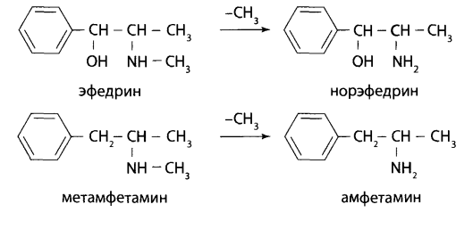

|  |  |
| --- | --- |
| **Ephedrine** | **Norephedrine** |



|  |  |
| --- | --- |
| **Methamphetamine** | **Amphetamine** |

2) aromatic hydroxylation

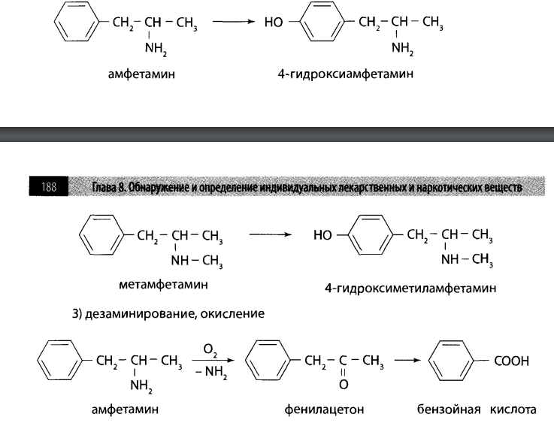

|  |  |
| --- | --- |
| **Amphetamine** | **Amphetamine 4-hydroxyamphetamine** |

3) deamination, oxidation



|  |  |  |
| --- | --- | --- |
| **Amphetamine** | **Phenylacetone** | **Benzoic acid** |

4) recovery

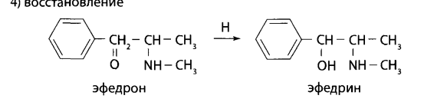

|  |  |
| --- | --- |
| **Ephedron** | **Ephedrine** |

Phase II - conjugation with amino acid (glycine)

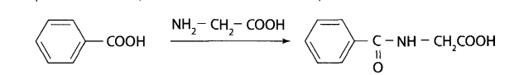

|  |  |
| --- | --- |
| **Benzoic acid (amphetamine metabolite)** | **Hippuric acid** |

Unchanged amphetamine and ephedrone are excreted in the urine in an amount of 20-30%, methamphetamine - about 45%, ephedrine - 55-75%, norephedrine - 90%.

**Physicochemical characteristics**

In the form of hydrochloric salts acids are white, odorless crystalline substances, readily soluble in water, ethanol, and practically insoluble in diethyl ether and chloroform. All derivatives phenylalkylamines - basic substances.

The bases of these substances, with the exception of ephedrine, are oily, non-volatile liquids. They are highly soluble in ethanol, chloroform, and diethyl ether. Ephedrine base is highly soluble in water.

**Isolation method**

Extraction:

* non-directional analysis by general methods with chloroform in the form bases from aqueous extracts at pH=8-10.
* targeted analysis of phenylalkylamine derivatives extracted from aqueous extracts at pH=12 with diethyl ether or chloroform.
* Solid phase extraction (for the isolation of phenylalkylamine derivatives from urine)

**Detection of phenylalkylamine`s compounds**

PRELIMINARY REACTION

* General TLC screening
* With precipitation reagents

CONFIRMATORY REACTIONS (for phenylalkylamine derivatives)

* Chromatography in a thin layer of sorbent
* UV spectrophotometry
* IR spectroscopy
* High performance liquid chromatography (HPLC)
* Gas chromatographic analysis coupled with mass spectrometry (GC/MS)
* Chemical method:

Reactions of coloring. They are carried out on porcelain cups with dry residues obtained after evaporation of extracts from biological objects.

Reaction with Mark's reaction. Mark's reagent is applied to the dry residue. In the presence of amphetamine, an orange color is observed, gradually turning into brown.

When methamphetamine is present, a yellow-green color is formed.

Reaction with ninhydrin . When adding sodium hydroxide to the dry residue

to pH = 8.5, ninhydrin solution and subsequent heating, ephedrine forms a blue-violet color, ephedron - purple, amphetamine - pink-orange, methamphetamine - green.

Microcrystalscopy reactions. Of the phenylalkylamine derivatives, only ephedrine forms crystalline precipitates with various reagents. For dry residue apply a drop of 0.1 M hydrochloric acid solution and a drop of the corresponding reagent. After 10-15 minutes, crystals of a characteristic shape are observed when examined under a microscope.

* Reaction with Dragendorff's reagent modified by A. S. Tishchenko. Composition of the reagent used: 1.5 g of sodium bismuthate (NaBi03), 7.5 g of potassium iodide (KI) dissolved in 100 ml of 2% sulfuric acid solution. Ephedrine with this reagent forms needle-shaped crystals and crystals in the form of irregularly shaped plates and intergrowths of them.

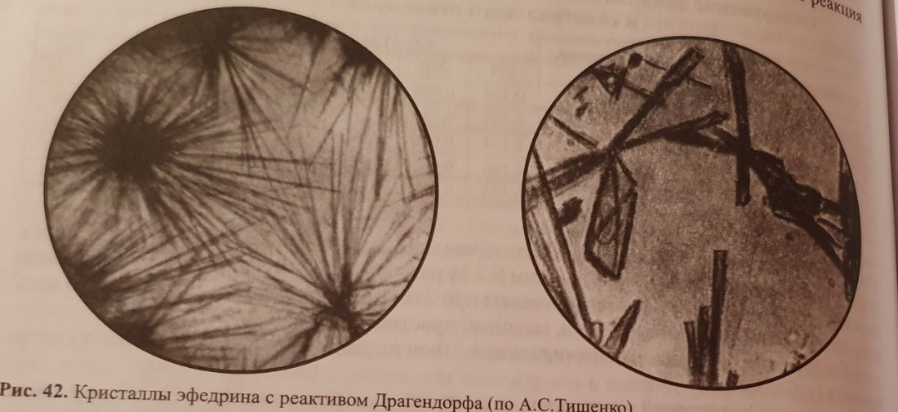

* Reaction with platinum chlorohydrogen acid and potassium iodide (A.S. Tishchenko). A drop of 0.5% solution of hydroplatinic acid (H2PtCl6) and several crystals of potassium iodide are added to a drop of the test solution on a glass slide. Through 15-20 min. observe the formation of red-violet crystals in the form of plates irregularly shaped, collected into clumps resembling branches in shape and sockets.

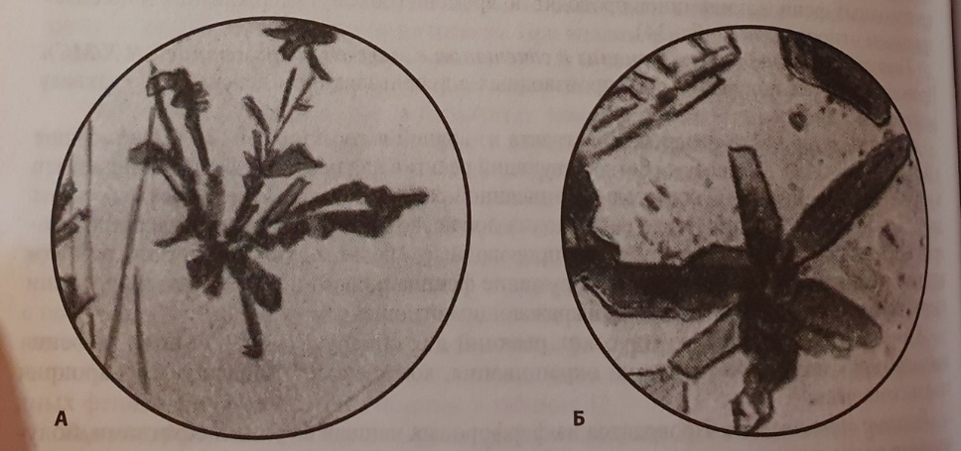

**Quantitative determination**

***HPLC method:***

* Additive Method
* External standard method
* Internal standard method

***Extraction-photometric method***

The benzene layer turns yellow. Optical density is measured using a spectrophotometer or photoelectrocolorimeter at a wavelength of 440 nm in a cuvette with layer thickness 10 mm. Calculation of the amount of ephedrine in urine is carried out using a calibration graphics

