Control tasks of independent work № 1
Electrical phenomena in excitable tissues

________________________________________________
(Full Name)

Volgograd, 2024
Introduction to the subject. electrical phenomena in excitable tissues

Questions for short written answer

1. Biological membranes, their structure and functions.
_________________________________________________________________________________________________________________________________________________________________________________________________________________________________________________________________________________________________________________________________________________________________________________________________

2. Resting membrane potential, its origin.
______________________________________________________________________________________________________________________________________________________________________________________________________________________________________________________________________________________________________________________________________________________________________________________________________________________________________________________________________________

3. Active state of tissue. Action potential, its phases, their origin.
______________________________________________________________________________________________________________________________________________________________________________________________________________________________________________________________________________________________________________________________________________________________________________________________________________________________________________________________________________

4. Synapse, classification of synapses. Chemical synapses, structure. Mechanism of signal transmission in chemical excitatory synapses.
___________________________________________________________________________________________________________________________________________________________________________________________________________________________________________________________________________________________________________________________________________________________________________________________________________________________________________________________________________________________________________________________________________________________

5. Structural and functional organization of muscles. Physical and physiological properties of skeletal muscles.
___________________________________________________________________________________________________________________________________________________________________________________________________________________________________________________________________________________________________________________________________________________________________________________________________________________________________________________________________________________________________________________________________________________________

6. Myoneural synapse, its features. The concept of the potential of the end plate, its role in generating an action potential on the muscle membrane.
___________________________________________________________________________________________________________________________________________________________________________________________________________________________________________________________________________________________________________________________________________________________________________________________________________________________________________________________________________________________________________________________________________________________

Terms dictionary

Types of electrical responses:

Action potential –

Resting membrane potential –

Depolarization –

Repolarization –

Hyperpolarization –

Overshoot –

1. Sign the designations on diagram.
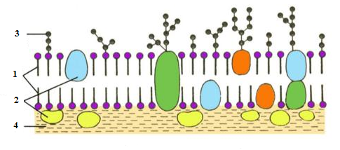

Diagram of biological membrane structure
1. _______________________________________________________
2. _______________________________________________________
3. _______________________________________________________
4. _______________________________________________________

2. Sign the symbols shown on the graph.

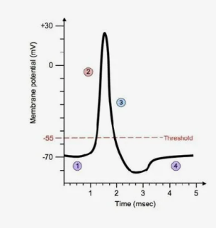

1.
2.
3.
4.

3. Sign the synapse elements indicated by numbers on the diagram.
Synapse structure diagram
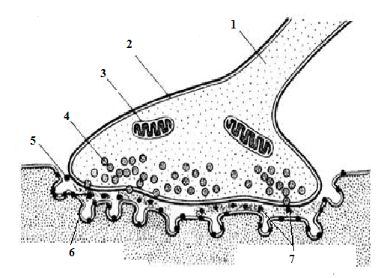
1.
2.
3.
4.
5.
6.
7.

4. Sign notation to the graph.

Force of stimulus | Duration of action
A | C
B | D

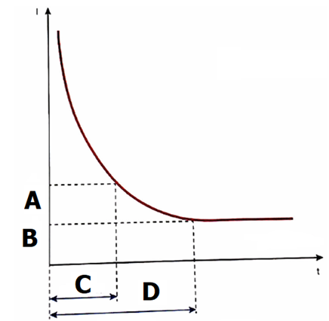

5. Describe types of nerve fibers.

Types of nerve fibers | Thickness | Presence of myelin | Excitation propagation mechanism | Excitation propagation velocity
А
B
С

6. Law of isolated conduction of excitation

7. Law of anatomical and physiological integrity of nerve

8. Law of bilateral conduction of excitation

Date:
Checked by (Full Name of Teacher):
Mark:
Signature of Teacher:

