**Detoxification methods for poisoning (enhancement of natural detoxification, artificial detoxification, antidote detoxification and pharmacotherapy)**

**Enhancing the body's natural detoxification**

One of the first steps when exposed to poisons inside is a cleansing of the gastrointestinal tract.

***Inducing vomiting***. Vomiting plays an important role as a protective reaction of the body in the removal of poison from the stomach and its further entry and distribution in the body. It can be spontaneous, caused by mechanical irritation of the root tongue and pharynx, or using special emetics. In case of poisoning with cauterizing liquids (strong acids, concentrated solutions of caustic alkalis), this method cannot be used, since during vomiting these substances will increase degree of damage to the esophagus, and can also enter the respiratory tract and cause their burn. It is not recommended to use substances that neutralize these poisons, e.g. baking soda for acid poisoning. This will produce gases (carbon dioxide), which will increase bleeding and pain.

***Gastric lavage***. Complications can be avoided by gastric lavage using a tube. Gastric lavage is effective for organochlorine poisoning and phosphorus-containing pesticides, narcotic and hypnotic substances. After washing, patients are given a suspension of activated carbon in water or other sorbents that absorb poisons and stop the absorption of the toxic substance remaining in the stomach.

***Colon cleansing*** is carried out using enemas, probe lavage, and also by taking various laxatives.

***Forced diuresis***. This method is used to remove toxic substances from the blood and tissues, when poisons are eliminated from the body primarily through the kidneys. The simplest technique is to administer large volumes (up to 1,5-2,0 litres) of saline or 5% glucose solution intravenously by drip. Various diuretics are used to stimulate diuresis. These include osmotic diuretics - 15-20% solutions of urea, mannitol or trisamine.

Alkalinization of urine achieves better dissociation of toxic substances and their metabolites, which leads to their excretion in the urine in large quantities.

**Furosemide (Lasix) has a strong diuretic effect.**

|  |
| --- |
| Its action is associated with inhibition of the reabsorption of sodium and chlorine ions, to a lesser extent degree - potassium. It is used in a single dose of 100-150 mg. |

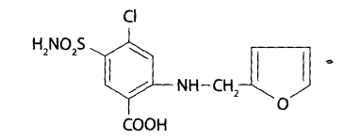

Method is used for poisoning with barbiturates, morphine, quinine, pachycarpine, dichloroethane, heavy metals and other substances excreted from the body by the kidneys. The effectiveness of the method decreases if the toxic substance forms a strong bond with blood proteins or lipids (for example, when poisoning with phenothiazine derivatives, etc.).

Forced diuresis is usually performed in three stages:

1. preliminary water load,
2. rapid administration of diuretics
3. replacement infusion with electrolyte solutions.

***Therapeutic hyperventilation***. In case of poisoning with poisons that are completely or partially eliminated through the lungs, stimulating the respiratory function allows for their rapid elimination from the body.

These poisons include: carbon monoxide, lower alcohols, carbon disulfide, chlorinated hydrocarbons, acetone, gasoline, paint thinners etc. Stimulation of breathing is achieved by inhalation of a mixture of oxygen (95%) and carbon dioxide (5%), which is called “carbogen”. If the patient loses consciousness connected to an artificial respiration apparatus. In order not to dramatically disturb the blood gas composition, hyperventilation is carried out intermittently: for 15-20 minutes every 1-2 hours during the toxicogenic stage of poisoning.

**Methods of artificial detoxification of the body**

**Dialysis** is the process of separating substances through a semi-permeable membrane. In toxicology semi-permeable the membrane can be the mucous membrane of the intestine, peritoneum or stomach.

**Sorption** is the absorption of gases, vapors or soluble substances by solids or liquids. Absorption may occur on the surface of a solid - adsorption or with the formation of chemical bonds - chemisorption. One of the most common sorbents in toxicology is activated carbon.

**Substitution** is the process of replacing a biological fluid containing toxic substances with another similar biological fluid or artificial environment to remove poison from the body. In toxicology, blood is replaced - hemapheresis or plasma - plasmapheresis with various blood substitutes or plasma substitutes.

Artificial detoxification can be carried out using intracorporeal or extracorporeal methods.

***Intracorporeal detoxification methods:***

* *Peritoneal dialysis*

Continuous dialysis is carried out using two catheters inserted into the abdominal cavity. Liquid is administered through one catheter, and through the other one is removed.

The intermittent method consists of periodic filling abdominal cavity with a special solution with a volume of up to 2 liters, which after exposure is deleted every time.

A mixture of potassium chloride solutions is used as a dialysate solution, sodium, calcium, magnesium, glucose in certain proportions. The composition and pH of this solution may vary depending on the nature of the toxic substance;

* *Intestinal dialysis*

In this method, the function of a natural semi-permeable membrane is performed by the intestinal mucosa, mainly the small intestine. To do this, use a double-lumen probe about 2 m long with a metal insert inserted into it mandrin. The probe is inserted into the intestine 40-50 cm below the pylorus of the stomach (under the control of a gastroscope). A dialysate solution (hypertonic in relation to blood plasma) is injected through the probe using a pump. After 20-30 minutes, the release of contents from the rectum begins. Intestinal dialysis is carried out for 2-3 hours using 8-12 liters of solution;

* *Detoxification enterosorption*

It is based on the introduction into the stomach immediately after washing it of 80-100 g of activated coal with water. This method helps to reduce the concentration of a toxic substance in the blood and improve the clinical condition of the patient.

***Extracorporeal detoxification methods:***

* Hemapheresis (plasmapheresis),
* Hemodialysis,
* Hemosorption,
* Plasmasorption,
* Exchange replacement blood,
* Lymphodialysis,
* Lymphosorption

**Methods of antidote therapy**

Depending on the time of entry of the poison into the body, the fight against poisoning is usually includes the following measures:

* immediate cessation of the entry (absorption) of the toxic substance into the blood;
* maximum reduction in the amount of toxic substances and their metabolites in blood and tissues;
* ensuring the normal functioning of vital organs and systems;
* timely provision of medical assistance at the scene of the incident and treatment in hospital;
* prevention of various complications.

Specific antidote therapy is effective in the early “toxicogenic phase” of acute poisoning.

**An antidote** is a drug that can either prevent the absorption of a toxic substance into the blood, or neutralize the poison, circulating in the bloodstream or associated with a biological substrate, or eliminate the toxic effect of the poison. Based on these properties, antidotes are divided into three groups: physicochemical, biochemical and pharmacological.

***Physicochemical (toxicotropic) antidotes***

Physico-chemical antidotes include agents used before the poison is resorption and neutralizing it in the stomach by sorption (enterosorbents) or by chemical reactions (specific detoxicants and complexons).

* Activated carbon is used as a suspension in water (1 tablespoon per 250 g water). 1 gram of coal sorbs 800 mg of morphine, 700 mg of barbital, 300-350 mg of alcohol, which prevents the absorption of these substances into the blood.
* Egg white contains protein and is also an antidote for poisoning with “metal” poisons and some alkaloids. The dose of protein must be significant (white from 10 eggs), and vomiting must be induced, otherwise the precipitate will dissolve and the poison can be absorbed into the blood.
* Enveloping agents: flax seed decoction, solutions of gelatin, starch;
* Astringents: tannin, oak bark decoction, strong tea are used for poisoning alkaloids, glycosides, metals.
* Magnesium oxide (MgO) - neutralizes acids, binds arsenic compounds. At this produces insoluble Mg3(AsO3) 2 and Mg3(AsO4)2,
* Magnesium sulfate - MgS04 (2 and 5%) - antidote for barium and lead salts. Are formed insoluble BaS04 and PbS04.
* Sodium chloride - NaCl (0.9%) - antidote for silver salts. Insoluble AgCl is formed.
* Calcium chloride - CaC12 (1.5-3%) - antidote for oxalic acid poisoning and fluorides. Insoluble calcium oxalate and calcium fluoride are formed: CaC2O4,
* Iodine solution precipitates salts of silver, lead, mercury, quinine, strychnine.

In case of poisoning with various compounds of arsenic, mercury, copper, cadmium, thiol compounds are used, in particular the domestic drug unithiol.

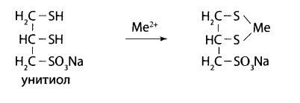

The antidote succimer (dimercaptosuccinic acid) acts similarly.

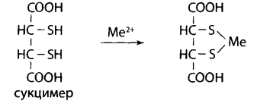

Penicillamine was more effective for lead poisoning.

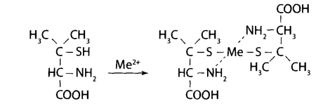

For poisoning with arsenous hydrogen, unithiol is ineffective. In this case the antidote can be atarsine or mercaptide, which forms a strong complex with arsenic.

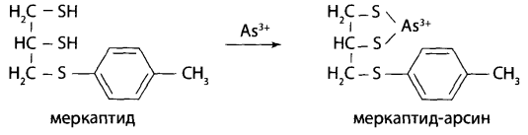

One of the universal chelating compounds is ethylenediaminetetraacetic acid (EDTA). The EDTA preparation is tetatsincalcium (calcium complex of disodium salt of ethylenediaminetetraacetic acid).

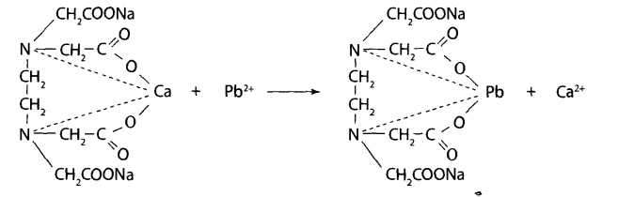

***Вiochemical antidotes***

The subgroup of “biochemical antidotes” includes substances that do not affect on the physicochemical properties of poisons, but ensure a change in the pathways of their metabolism.

Antidotes for poisoning with methemoglobin-forming poisons

Methemopubin-forming poisons include:

* nitro compounds (nitrogen oxides, nitrites, nitrates, trinitrotoluene);
* amino compounds (aniline, hydroxylamine, etc.);
* oxidizing agents (chlorates, permanganates, quinones);
* dyes with redox properties (methylene blue);
* medications (nitroglycerin, amyl nitrite, sulfonamides, aspirin, barbiturates, etc.)

They are used as antidotes for poisoning: glucose, thiols, and methylene blue in small doses.

For cyanide poisoning can be used sodium thiosulfate as a specific antidote.



In case of poisoning with organophosphorus compounds and carbamic acid derivatives, antidote therapy is based on the use of two groups of therapeutic agents: anticholinergics and cholinesterase reactivators.

The best anticholinergic drug was atropine;

Currently, cholinesterase reactivators, which are strong nucleophilic reagents, have found use: dipyroxime, alloxime, isonitrosine.

|  |
| --- |
| **Dipyroxime** |

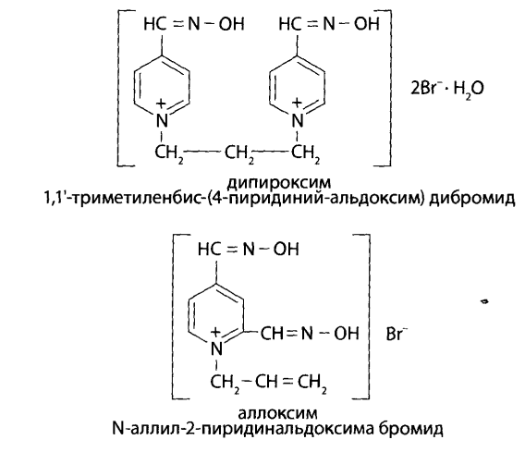

|  |
| --- |
| **Alloxime** |



|  |
| --- |
| **Isonitrosine** |

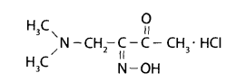

Among pharmacological antidotes, it should be noted substances that act the opposite of a toxic substance on the body. They slow down or interrupt the course of poisoning. These compounds are often close in chemical structure to poisonous substance.

In case of barbiturate poisoning, a functional barbiturate antagonist analeptic, stimulating the central nervous system - bemegride, is administered.

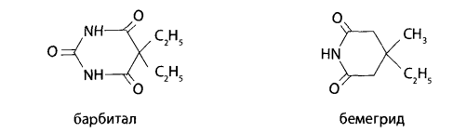

In case of poisoning with drugs of the opium group (morphine), the morphine antagonist nalorphine (anthorphine) is used as an antidote. In case of poisoning with small doses morphine, analeptics are administered - caffeine, cordiamine, etc.

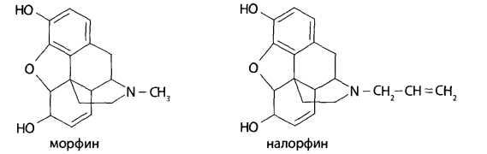

In case of poisoning with methyl alcohol or ethylene glycol, ethyl alcohol is used as an antidote. It is administered intravenously as a 5% solution (sometimes up to 30%).