**Group of toxicologically important substances isolated extraction with water. Mineral acids and alkalis.** **Nitrates, nitrites. Toxicity. Chemical-toxicological analysis.**

Chemical-toxicological examination of biological objects for mineral acids, alkalis and some salts is carried out by decree of legal authorities, if materials of the criminal case indicate the possibility of poisoning with the listed substances or if there are clear signs of poisoning with these substances.

**MINERAL ACIDS**

Mineral acids are widely used in various industries and in everyday life, and therefore are often available to the population. This is one of the reasons both accidental and intentional poisonings. There are known criminal cases of using sulfuric acid to cause physical harm. Other acids can be used for the same purpose. Accidental household poisonings are less common. In case of acid poisoning, acute poisoning is most often observed.

**Sulfuric acid**

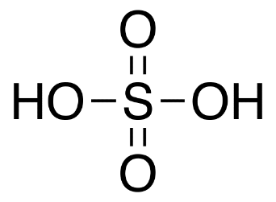

**Properties and toxicological significance**

Sulfuric acid is produced industrially in the form of so-called monohydrate - 98% solution of sulfuric acid, oleum - 20% solution of sulfuric anhydride in sulfuric acid acid, crude sulfuric acid or oil of vitriol - 93-97% sulfuric solution acids. Sulfuric acid mixes with water in any ratio, and a large amount of heat is released. Sulfuric acid is used in almost all areas chemical industry.

*Acute intoxication*. When vapors are inhaled, difficulty breathing is observed, accompanied by coughing, hoarseness, and often develops laryngitis, tracheitis, bronchitis. At high concentrations of vapors, swelling of the larynx, lungs, and sometimes death occurs as a result of asphyxia and shock. If sulfuric acid comes into contact with your skin it quickly penetrates into the depths of the tissue, a white scab is formed, which then acquires a dark red color. Deaths occur when large areas are affected areas of the body surface or when ingesting 5-10 ml of sulfuric acid.

When examining a corpse, traces of a chemical can be found on the skin around the mouth. burns in the form of brown stripes and spots. The mucous membranes of the mouth, pharynx, and esophagus have gray-brown color, gastric mucosa - grayish-red color

**Objects of research:** kidney, 1/3 part of liver, 1 meter of intestines, vomit, stomach contents, blood, urine.

**Isolation method**

**«Water extraction combined with dialysis»**

To isolate objects, crush them and add purified water to obtain mushy mass, which is left for 1-2 hours and then filtered. For the cleaning the extracts obtained are used by dialysis.

Dialysis is the release of aqueous extracts containing toxic substances, from high molecular weight compounds using a semi-permeable membrane.

To carry out dialysis, a porous partition is placed between the extract and purified water - a membrane, the pores of which are permeable to ions and low molecular weight molecules substances, but do not allow proteins and macromolecules to pass through. Distribution (concentration) of ions toxic substances on both sides of the membrane is determined by membrane equilibrium.

Partitions made from an animal bladder, parchment paper, or nitro- or cellulose acetate film (collodion, cellophane) are used as membranes for dialysis. Currently semi-permeable membranes can be manufactured with any degree of permeability, those. with any pore diameter. Porous metal partitions are also used.

The disadvantage of this method is the possibility of protein molecules (particles) sticking to the walls of the pores and their coagulation upon contact with the surface of the membrane. That's why when choosing a membrane, the properties and nature of impurities in extracts from objects are taken into account.

**Detection of sulfuric acid`s compounds**

PRELIMINARY REACTION

First, the dialysate is tested for individual acid ions:

• ***Test for sulfates.*** To 1 ml of dialysate add 0.1 ml of 10% hydrochloric acid solution and 1 ml of 5% barium chloride solution. In the presence of sulfathions, a white precipitate is formed.

• ***Chloride test***. To 1 ml of dialysate add 0.1 ml of 10% nitrogen solution acid and 0.1 ml of 1% silver nitrate solution. In the presence of chlorides, it forms white cheesy sediment, soluble in ammonia solution.

• ***Test for nitrates and nitrites.*** A drop of dialysate is added to a solution of diphenylamine in concentrated sulfuric acid. In the presence of nitrates or nitrites, the mixture turns blue.

CONFIRMATORY REACTIONS

|  |
| --- |
| **Device for distilling acids from dialysate:**  1 - flask for dialysate distillation;  2 - Liebig refrigerator;  3 - allonge;  4 - receiver for distillate. |

The dialysate is placed in a flask and copper filings are added to it. The flask is connected to a refrigerator equipped with an allonge, the end of which is dipped into a solution of iodine in iodide potassium.

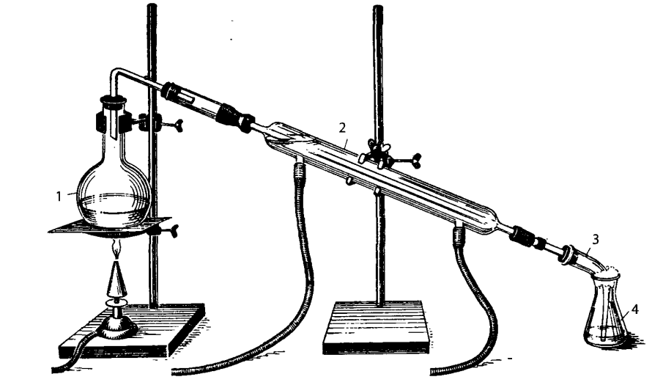

The flask with dialysate and copper filings is heated. If the iodine solution in the receiver discolored, it must be added additionally.

In the flask with the object, an oxidation-reduction reaction occurs with the formation of sulfurous acid, which decomposes to sulfur oxide (IV).

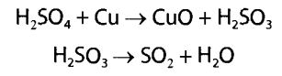

A redox reaction also takes place in the receiver and discoloration of iodine is observed.



Detection of the formed sulfuric acid is carried out using the following reactions.

***The reaction of formation of barium sulfate***. Add 1-2 drops to 3-5 drops of solution 5% barium chloride solution. A white precipitate appears, indicating the presence of sulfur acids.

***Reaction to produce lead sulfate***. Add 2-3 drops to 3-5 drops of solution 3% lead acetate solution - a white precipitate of lead sulfate forms, insoluble in nitric acid, but soluble in alkali solutions and in ammonium acetate solution.

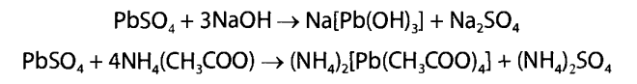

The latter reaction is based on the ability of lead ions to form acetate acid complexes.

***Reaction with barium rhodium chloride***. Add red colored solution to 1-2 ml of solution color 0.2% barium rhodizonate solution. If there are sulfate ions in the solution, the color disappears, the solution becomes discolored and a white precipitate of barium sulfate is formed.

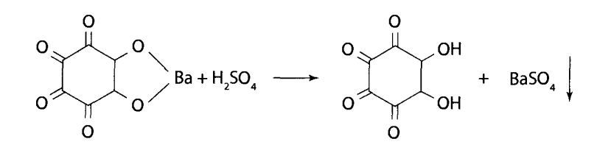

**Quantitative determination**

***Alkalimetry.*** A certain volume of dialysate or distillate is titrated with 0.1 M hydroxide solution sodium with methyl orange indicator.

**Nitric acid**

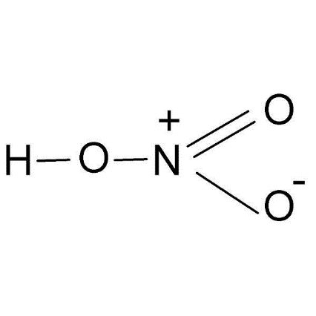 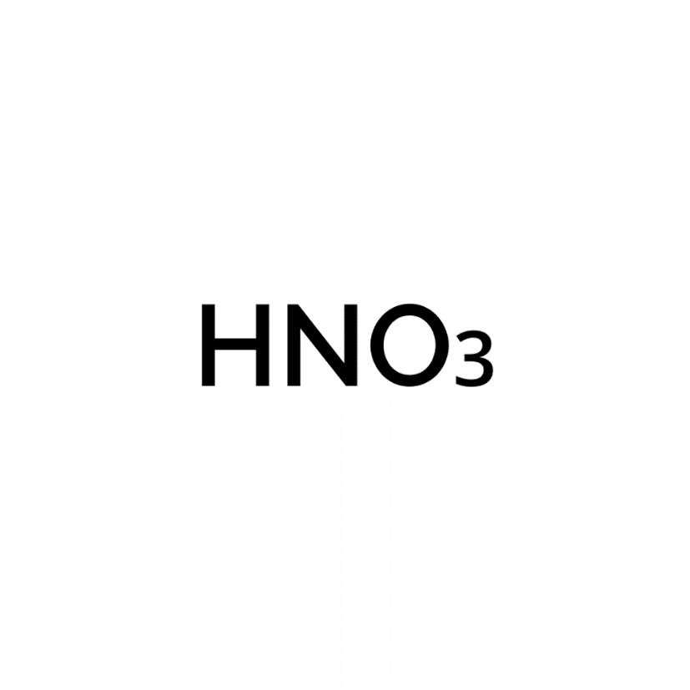

**Properties and toxicological significance**

Nitric acid is a colorless transparent liquid. It mixes with water in every way. An open container of nitric acid releases heavy vapors producing white smoke. Nitric acid is produced industrially in the form of 50-60% and 96-98% solutions. Nitric acid is used in chemical industry in the production of fertilizers, explosives, medicines, etc. Compared to sulfuric acid, it is less accessible to the population.

When nitric acid acts on fabrics, they acquire a yellow color due to decomposition and nitration products. Nitric acid poisoning can be inhaled or oral.

*Acute intoxication.* In case of inhalation poisoning with nitric acid, cyanosis of the mucous membranes of the eyelids and lips is observed, in the trachea and bronchi there is a large amount of fine bubble foam, lungs increased in volume, bluish-red with a large amount of foam. There is swelling of the pia mater and brain, and congestion of the internal organs. Poisoning begins with sharp pain in the mouth, pharynx, esophagus, and stomach.

When taken orally, the lethal dose of nitric acid is 8-10 ml.

Vomiting occurs in brown masses containing fragments of the mucous membrane. Death occurs from shock or collapse.

When opened, the contents of the stomach have a pungent odor of nitrogen oxides, and a yellowish coloration of the skin around the mouth, oral mucosa and digestive tract is observed. The heart muscle and liver are flabby and have a grayish-red color with a brown tint.

**Objects of research:** kidney, 1/3 part of liver, 1 meter of intestines, vomit, stomach contents, blood, urine.

**Isolation method**

«Water extraction combined with dialysis»

**Detection of nitric acid `s compounds**

PRELIMINARY REACTION

First, the dialysate is tested for individual acid ions:

• ***Test for sulfates****.* To 1 ml of dialysate add 0.1 ml of 10% hydrochloric acid solution and 1 ml of 5% barium chloride solution. In the presence of sulfathions, a white precipitate is formed.

• ***Chloride test***. To 1 ml of dialysate add 0.1 ml of 10% nitrogen solution acid and 0.1 ml of 1% silver nitrate solution. In the presence of chlorides, it forms white cheesy sediment, soluble in ammonia solution.

• ***Test for nitrates and nitrites****.* A drop of dialysate is added to a solution of diphenylamine in concentrated sulfuric acid. In the presence of nitrates or nitrites, the mixture turns blue.

CONFIRMATORY REACTIONS

Distillation of the dialysate is carried out, as in the case of sulfuric acid, in the presence of copper filings. Purified water is placed into the receiver. Reactions occur in the reaction flask leading to the formation of nitrogen oxides.

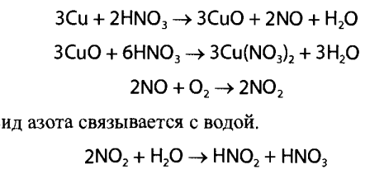

In the receiver, nitric oxide binds with water.



To detect the formed nitric and nitrous acids, the following reactions are used.

***Reaction with diphenylamine***. Apply 3-4 drops into the recess on the glass slide a solution of diphenylamine in concentrated sulfuric acid and add 1 drop of the solution obtained as a result of distillation - a blue color appears.

This reaction is nonspecific.

***Reaction with brucine***. Place a few drops into a well on a glass slide. test solution and add 2-3 drops of brucine in concentrated sulfuric acid acid - a red color appears in the presence of nitric acid in the dialysate.

***Reaction with protein to nitric acid (xanthoprotein test).*** White silk, cotton and wool threads are placed in part of the test solution and the solution is evaporated. The threads are then washed with water. Wool and silk threads are dyed yellow. When adding ammonia solution, the color of the threads changes to orange. Cotton threads remain white.

***Reaction to nitrous acid.*** A few drops of the test substance are added to the test tube. solution, add 2-4 drops of 10% sulfuric acid solution and 2-3 drops of 1% aqueous phenazone solution - the formation of a green color is observed.

**Quantitative determination**

***Neutralization method***. A certain volume of dialysate or distillate is titrated with 0.1 M sodium hydroxide solution with indicator phenolphthalein.

**Hydrochloric acid**



Hydrochloric acid is a solution of hydrogen chloride in water. The industry produces several types of hydrochloric acid. Most known: “battery”, containing approximately 37% hydrogen chloride, and concentrated, containing approximately 25% hydrogen chloride. The first of them has quite a lot of impurities and is used only for technical purposes. The second is more purified; one of its varieties is used in pharmaceutical practice. Diluted hydrochloric acid (1:2) is prepared from a 25% solution and is available to the public.

*Acute intoxication*. When inhaling hydrogen chloride, irritation of the upper respiratory tract and lungs is observed. Death can occur from asphyxia as a result of laryngeal edema or spasm of the glottis.

When ingesting concentrated hydrochloric acid, death can occur from 15-20 ml of such a solution. Symptoms of poisoning are the same as for sulfuric acid poisoning, but to a lesser extent.

At autopsy, it is clear that the mucous membranes of the oral cavity, esophagus, and stomach and upper intestine are grayish or black in color. Stomach contents is a brown mass. The kidneys, liver and heart are in a fatty state dystrophy. The heart muscle is flabby and yellowish in color.

**Objects of research:** kidney, 1/3 part of liver, 1 meter of intestines, vomit, stomach contents, blood, urine.

**Isolation method**

«Water extraction combined with dialysis»

**Detection of hydrochloric acid `s compounds**

PRELIMINARY REACTION

First, the dialysate is tested for individual acid ions:

• ***Test for sulfates****.* To 1 ml of dialysate add 0.1 ml of 10% hydrochloric acid solution and 1 ml of 5% barium chloride solution. In the presence of sulfathions, a white precipitate is formed.

• ***Chloride test***. To 1 ml of dialysate add 0.1 ml of 10% nitrogen solution acid and 0.1 ml of 1% silver nitrate solution. In the presence of chlorides, it forms white cheesy sediment, soluble in ammonia solution.

• ***Test for nitrates and nitrites****.* A drop of dialysate is added to a solution of diphenylamine in concentrated sulfuric acid. In the presence of nitrates or nitrites, the mixture turns blue.

CONFIRMATORY REACTIONS

A portion of the dialysate is placed in a flask and heated in a sand bath. First from the flask water is distilled into the receiver. When the concentration of hydrogen chloride in the reaction the flask reaches 10%, it begins to distill and enters the receiver, where it dissolves in water.

Detection of hydrochloric acid is carried out using the following reactions.

***Reaction with silver nitrate***. Place 1-2 ml of solution in a test tube, add 1-2 drops of 5% silver nitrate solution and 1 ml of 10% nitric acid - white appears a precipitate that is soluble in ammonia solution and appears again after the solution is acidified with nitric acid.

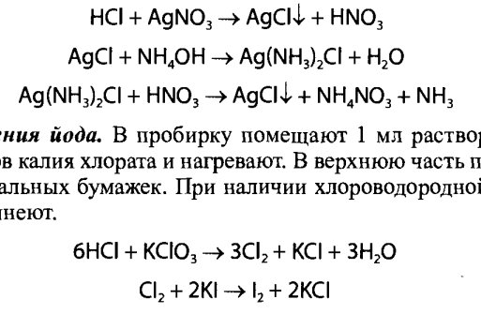

***Iodine release reaction***. 1 ml of solution is placed in a test tube, several crystals of potassium chlorate are added and heated. Place in the top of the test tube several iodine starch pieces of paper. In the presence of hydrochloric acid, starch iodide papers turn blue.



**Quantitative determination**

***Folgard`s method***.

***Gravimetric method*** is used due to hydrogen sulfide presentation in the test solution. To this end excess silver nitrate is added to the solution. In this case, chloride is formed in the precipitate silver (AgCl) and silver sulfide (Ag2S). The precipitate is filtered off and treated with 10% ammonia solution to dissolve silver chloride. The ammonia solution is acidified nitric acid and the resulting precipitate of silver chloride is filtered off and dried to constant weight and weigh.

**Nitrates, nitrites**

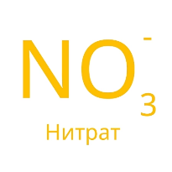 

Sodium nitrate and nitrite are colorless or slightly yellowish crystals, have a salty taste, similar to the taste of sodium chloride, and are highly soluble in water.

Sodium nitrite is used in the chemical industry in the production of dyes, photographic emulsions, and sometimes in construction as an antifreeze for concrete in winter, in the rubber, textile and metalworking industries. Nitrites and nitrates are not currently used as food preservatives.

Nitrates are used in many industries. Nitrates (ammonium, alkali metals and calcium) are the main nitrogen fertilizers. Nitrates are components of rocket fuel, pyrotechnic compositions, etching solutions for dyeing fabrics, they are used for hardening metals, as medicines funds in other areas.

Nitrites and nitrates are toxic compounds. They are quickly absorbed from the gastrointestinal tract. Poisoning with nitrites and nitrates can be industrial and domestic. Nitrates cause pulmonary edema, cough, vomiting, and acute cardiovascular failure. The lethal dose of nitrates is in the range of 8-15 g. It has been established that in the body nitrates can be reduced to nitrites. Nitrites cause headaches, vomiting, depress breathing, act on vascular walls and inhibit the vasomotor center.

*Chronic intoxication:* methemoglobin is formed in the blood,

red blood cell membranes are damaged. It is possible that nitrosamines and amines can be formed from nitrites directly in the gastrointestinal tract. In case of poisoning, a blue-black color is characteristic lips, nose, ears, nails, the blood turns chocolate color.

**Objects of research:** kidney, 1/3 part of liver, 1 meter of intestines, vomit, stomach contents, leftover food, parts of clothing.

**Isolation method**

«Water extraction combined with dialysis»

**Detection of nitrates, nitrits` compounds**

CONFIRMATORY REACTIONS

**NITRATES**

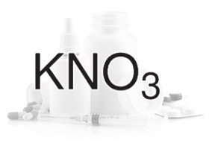 **NaNO3**

***Reaction with sulfanilic acid and β-naphthol***. Into a recess on a glass slide place 2 drops of pre-neutralized dialysate, add 2-3 drops 0.5% solution of sulfanilic acid in 2% solution of hydrochloric acid. Through after 3-5 minutes, 1 drop of an alkaline solution of R-naphthol is added to the mixture - an intense orange-red color appears.

***Reaction with Griess reagent (a mixture of sulfanilic acid and 1-naphthylamine).*** A few drops of neutralized acetic acid are added to the recess of the glass slide. dialysate acid and add 3-4 drops of Griess reagent. In a few minutes intense red color appears.

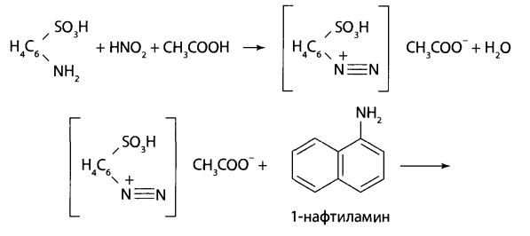

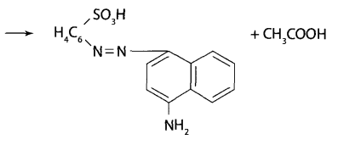

***Reaction with phenazone.*** A 10% sulfuric acid solution and a few drops of a 1% phenazone solution are added to part of the dialysate - the appearance of a green color is observed.

Using these reactions, endogenous nitrites can be detected.

Therefore, additional distillation of the dialysate is used after acidification with acetic acid. The distillate should give the same reactions to nitrites. The technique does not allow detect trace amounts of naturally occurring nitrites.

**NITRITES**

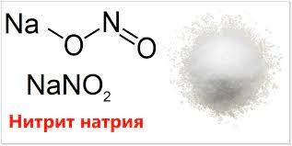 **KNO2**

Before nitrates are detected in dialysate, nitrites must be removed using sodium azide - NaN3 or sulfamic acid - NH2S03H.

***Diphenylamine reaction*** in sulfuric acid to produce a blue color.

***With iron(II) sulfate***. Part of the test solution is placed in a test tube (usually 2-3 drops) and a crystal of iron(I) sulfate. Then along the wall of the test tube slowly add a drop of concentrated sulfuric acid. A brown ring appears at the point where the two liquids come into contact. Nitrates are reduced to nitrogen oxide (II), which with excess iron (II) sulfate forms a brown solution.



**Quantitative determination**

***Photocolorimetry.***

***Colorimetry.***

***Reaction with Griess reagent.***

**ALKALIS**

**Sodium hydroxide**



Sodium hydroxide is a crystalline solid, soluble in water, alcohol, glycerin. Upon contact with skin or mucous membranes, it forms soft scabs. Getting sodium hydroxide into the eyes is dangerous, as it can cause secondary glaucoma and shrinkage of the eyeball. If ingested, symptoms of poisoning are similar to those of acid poisoning. Lethal dose of sodium hydroxide and other caustic alkalis is 10-20 g.

**Objects of research:** kidney, 1/3 part of liver, 1 meter of intestines, vomit, stomach contents.

**Isolation method**

**«Water extraction combined with dialysis»**

To isolate objects, crush them and add purified water to obtain mushy mass, which is left for 1-2 hours and then filtered. For the cleaning the extracts obtained are used by dialysis.

To carry out dialysis, a porous partition is placed between the extract and purified water - a membrane, the pores of which are permeable to ions and low molecular weight molecules substances, but do not allow proteins and macromolecules to pass through. Distribution (concentration) of ions toxic substances on both sides of the membrane is determined by membrane equilibrium.

Partitions made from an animal bladder, parchment paper, or nitro- or cellulose acetate film (collodion, cellophane) are used as membranes for dialysis. Currently semi-permeable membranes can be manufactured with any degree of permeability, those. with any pore diameter. Porous metal partitions are also used.

The disadvantage of this method is the possibility of protein molecules (particles) sticking to the walls of the pores and their coagulation upon contact with the surface of the membrane. That's why when choosing a membrane, the properties and nature of impurities in extracts from objects are taken into account.

**Detection compounds**

CONFIRMATORY REACTIONS

***Reaction with potassium hydroxybiate***. To 3-5 drops of dialysate, neutralized acetic acid, add 2-3 drops of calvd hydroxystibiate solution. When the walls of the test tube are rubbed with a glass rod, a white crystalline precipitate falls out.

The most probable formula of potassium hydroxybiate is K[Sb(OH)6], which, when interacting with the resulting sodium acetate, forms a white precipitate.

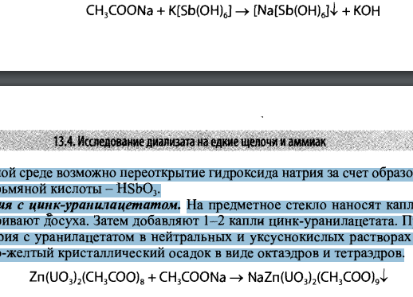

In an acidic environment, re-opening of sodium hydroxide is possible due to the formation of a precipitate of metaantimony acid - HSb03.

***Reaction with zinc uranyl acetate***. A drop of dialysate is placed on a glass slide and evaporated to dryness. Then add 1-2 drops of zinc-uranyl acetate. In the presence of sodium ions with uranyl acetate in neutral and acetic acid solutions is formed greenish-yellow crystalline precipitate in the form of octahedra and tetrahedrons.



**Quantitative determination**

***Neutralization method***. A certain volume of dialysate or distillate is titrated with 0.1 M hydrochloric acid solution with indicator phenolphthalein.

**Potassium hydroxide**

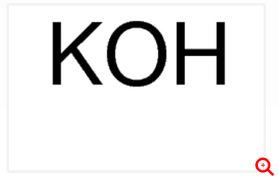

Potassium hydroxide is a white crystalline substance, very easily soluble in water. In potassium hydroxide poisoning, the picture is similar to hydroxide poisoning sodium, but many reactions on the body are more pronounced.

**Objects of research:** kidney, 1/3 part of liver, 1 meter of intestines, vomit, stomach contents, leftover food, parts of clothing.

**Isolation method**

«Water extraction combined with dialysis»

**Detection compounds**

CONFIRMATORY REACTIONS

To detect potassium ions, reactions with sodium hydrogen tartrate and sodium cobaltinitrite are used.

***Reaction with sodium hydrogen tartrate***. Add 3-5 drops into a small test tube dialysate, add 3-4 drops of 1 M sodium hydrogen tartrate solution and the same volume a mixture of equal quantities of 2 M tartaric acid solution and 2 M sodium acetate solution.



The walls of the test tube are rubbed with a glass rod. In the presence of potassium ions, it precipitates white precipitate.

***Reaction with sodium cobaltinitrite***. 3-5 drops of the test dialysate are added to a small test tube and 2-3 drops of sodium cobaltinite solution are added - Na3[Co(N02)6].

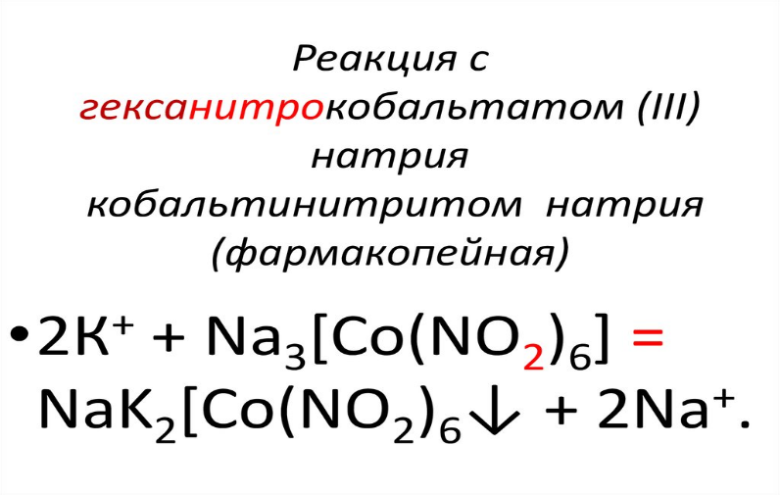

In the presence of potassium ions, a yellow crystalline precipitate forms - K2Na[Co(N02)6].

**Quantitative determination**

***Neutralization method***. A certain volume of dialysate or distillate is titrated with 0.1 M hydrochloric acid solution with indicator phenolphthalein.

**Ammonia**

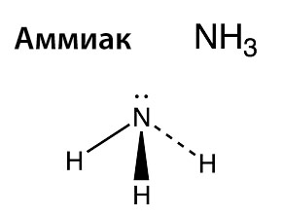

Ammonia. A saturated ammonia solution contains up to 33% ammonia, 10% its solution known as ammonia. Ammonia is widely used in chemical synthesis and in the refrigeration industry.

In medical practice it is used for fainting conditions. Ammonia solution is a weak alkali.

It causes a painful inflammatory reaction with the formation of severe swelling.

*Chronic intoxication* detachment of the mucous membranes, formation of blisters and necrosis are observed.

*Acute intoxication*. At high concentration of ammonia in the air causes paralysis of the central nervous system and rapid death when phenomena of asphyxia (cyanosis, convulsions, respiratory arrest). The clinical picture is similar with the effect of other caustic poisons: swelling of the larynx, psychomotor agitation, convulsions, delirium, then collapse, paresis of the lower extremities. Death occurs within 10-15 minutes.

At autopsy, bright red membranes of the mouth, pharynx, esophagus, stomach, pulmonary edema, in the kidneys - nephrosis and necrosis of convoluted tubules, in the brain – small hemorrhages, ammonia smell from cavities. The lethal dose is 10-15 ml 33% solution and 25-50 ml of 10% ammonia solution.

**Objects of research:** kidney, 1/3 part of liver, 1 meter of intestines, vomit, stomach contents.

**Isolation method**

«Water extraction combined with dialysis»

**Detection compounds**

CONFIRMATORY REACTIONS

The analysis is carried out with dialysate if preliminary tests indicate its possible presence.

***Reaction with Nessler's reagent***. Add 1-2 drops of the test solution to the test tube, add 3-5 drops of purified water and 3-4 drops of Nessler’s reagent. In the presence of ammonia, a yellow-brown or orange-brown precipitate forms.

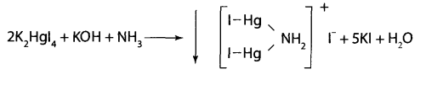

The reaction is nonspecific, since many ions can precipitate in the presence of alkali or react with iodide ions, forming a similar color.

**Quantitative determination**

***Neutralization method***. A certain volume of dialysate or distillate is titrated with 0.1 M hydrochloric acid solution with indicator methyl orange.